AS A MEMBER OF THE PUYALLUP PTA COUNCIL BOARD OF DIRECTORS I SHOULD REMEMBER:
- I am one of a board, and each member has a contribution to make. I will feel that I am important to the board, and I will respect the other members.

- That what I think is necessary as what others think, so I will try to present my ideas as clearly and constructively as possible.

- That to remain silent or withhold differing opinions is not helpful to the board in thinking through problems, and I should not feel resistant when someone differs with me.

- That to participate too much, monopolize the discussion, or be too insistent on my viewpoint can be detrimental to the functioning of the board, so this should be avoided.

- I am learning and working with others and, therefore, I need to cooperate and be concerned about harmonious relations in the board.

- I should volunteer readily when I think my services and abilities will be useful to the board and I have the time that will be required.

- When I have undertaken a responsibility, I should carry through with it until successfully completed.

- I should be willing to confer with others, accept the offers of assistance of others, and generously acknowledge the contributions of other whenever recognition is due.

- I should suspend judgment until facts are known and base decisions upon objective data.

- I should make sure I fully understand the problem before offering a solution.

- I should be careful not to make irresponsible statements, repeat confidential information or stir up feelings which are antagonistic to good board work.

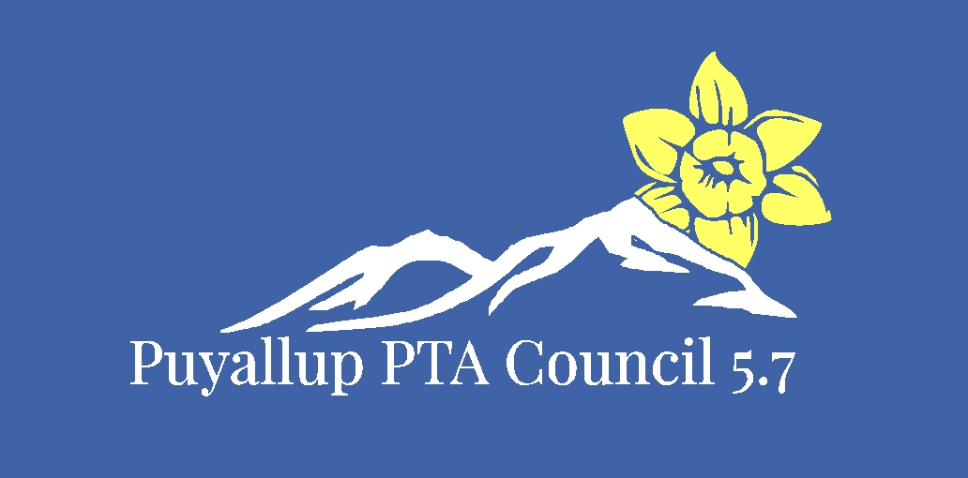
Memorandum of Understanding 2019-2020
Board approved 08/04/2019 Member approved

