Puyallup PTA COUncil Mission and Goals | - 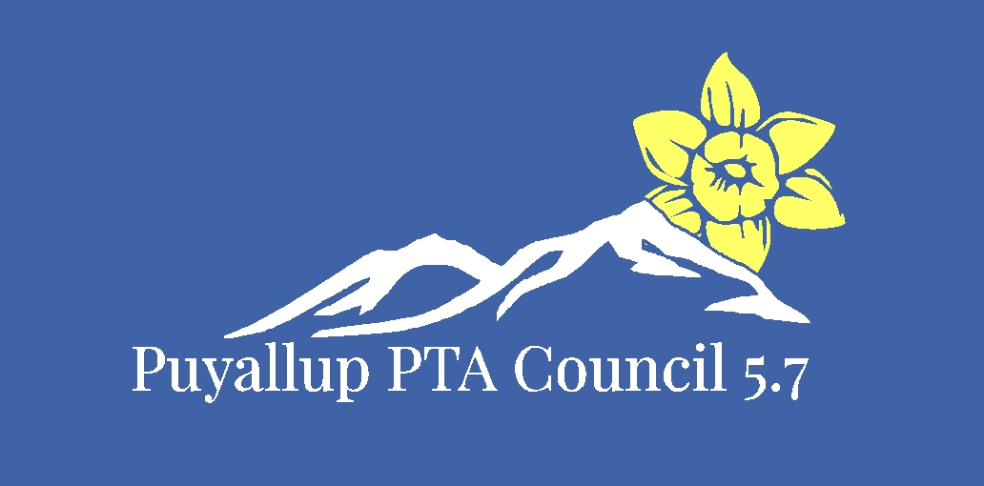  - Board approved 8/4/2019  - Member approved
- Puyallup PTA Council Goals 2019-2020  Fostering growth and diversity within membership.  - Increase membership by 4%  - Educate local PTAs to diversify membership within their schools.  - Raise awareness of options local PTAs can take to accommodate the special needs populations in the services they provide.  Increase participation by diversifying training.  - Provide multiple options for training participation.  Encourage local PTA’s Participation.  - Increasing local PTA participation at WSPTA Legislative Assembly, WSPTA Focus Day and WSPTA issue submittal from last year’s totals.  - Host at least one town hall  Promote leadership development at the local PTA and Council levels.  - Increase balance in local PTAs volunteerism and leadership growth by encouraging the adoption of a “sustainability initiative. | Mission Statement is…  To support, mentor, educate and empower local PTAs.  We will accomplish this by:  Fostering growth and diversity within membership.  Increase participation by diversifying training.  Encourage local PTA’s participation.  Promote leadership development at the local PTA and council levels.

